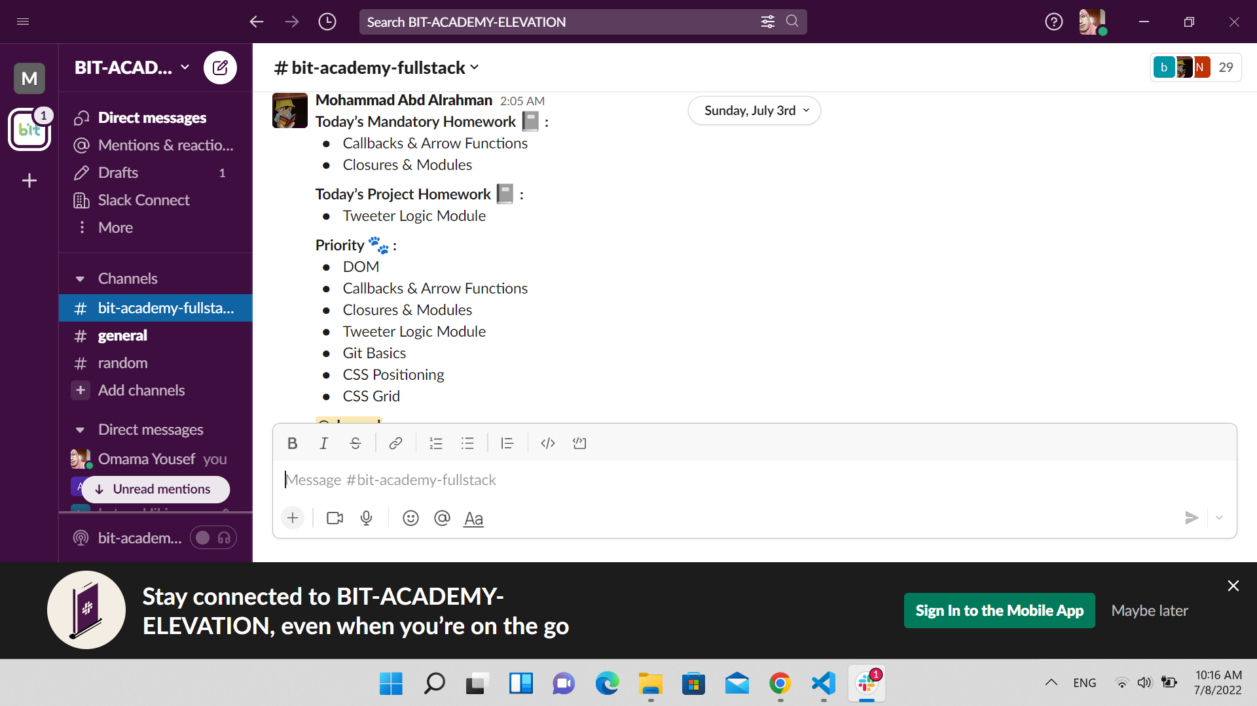

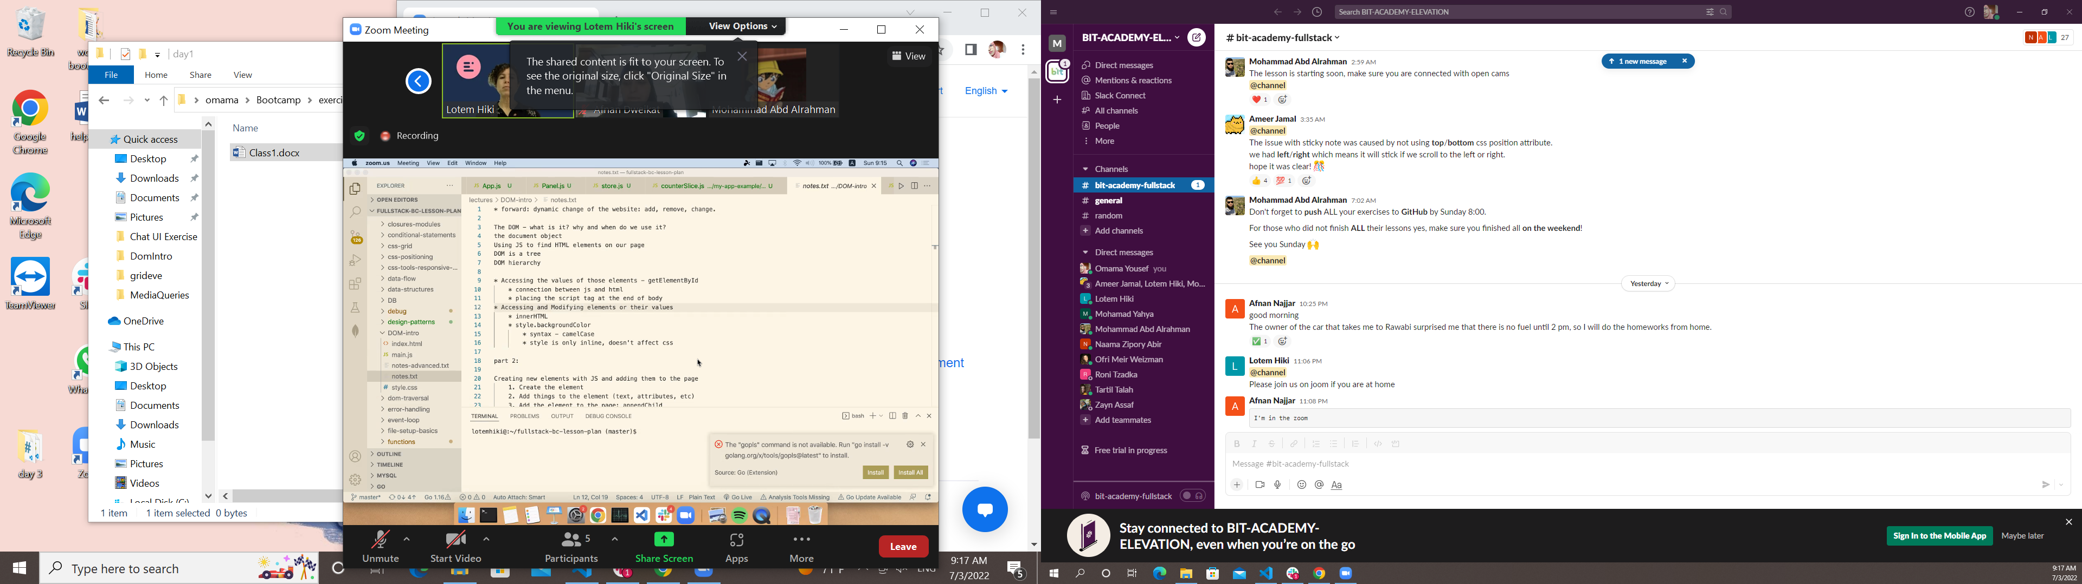

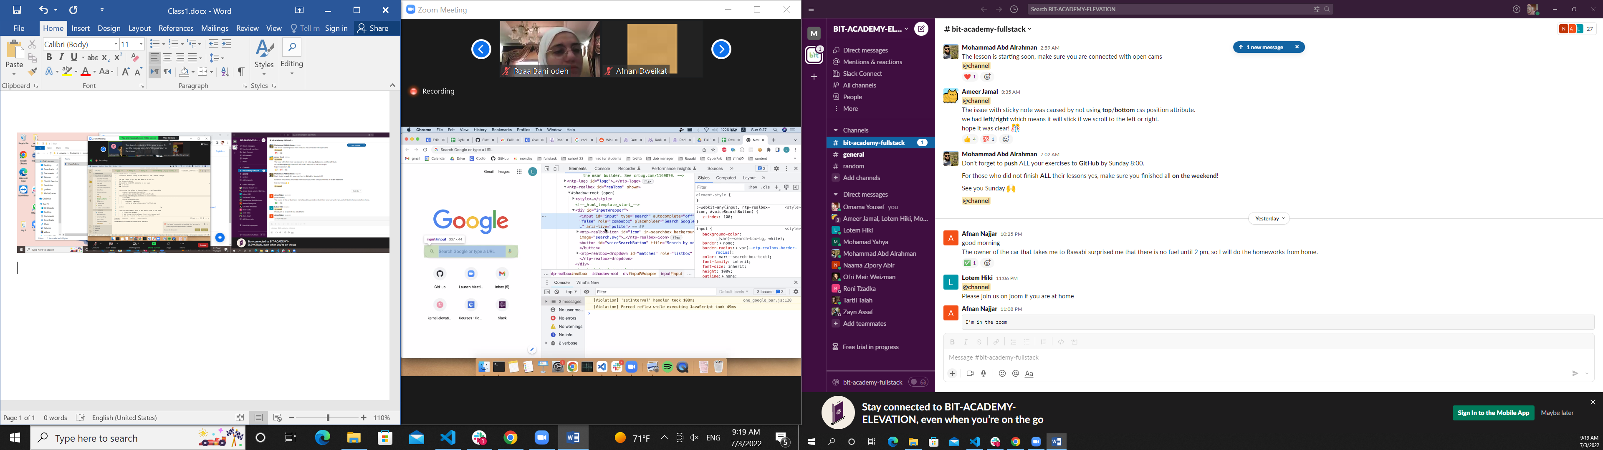

Document.body we can acsess any html tag from document

How it built

Family realeation ship

Tree of nodes

Terminology in interview

Root Ancestors a b c

A b c Decedent’s root

Leaf the last node

a-b sibling

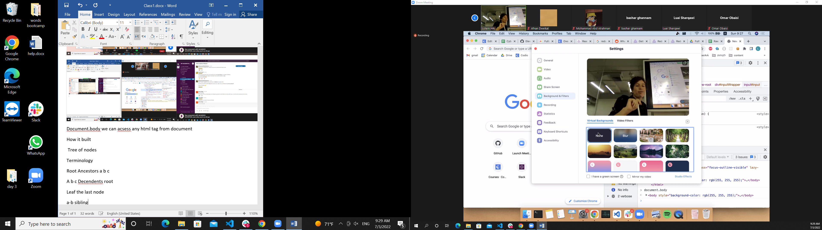

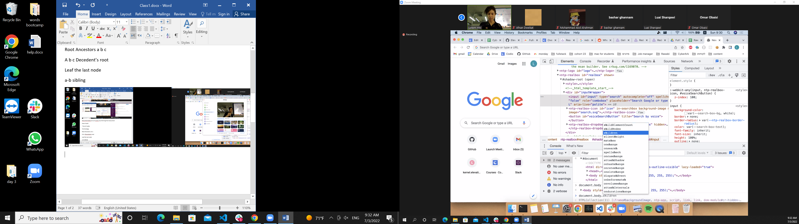

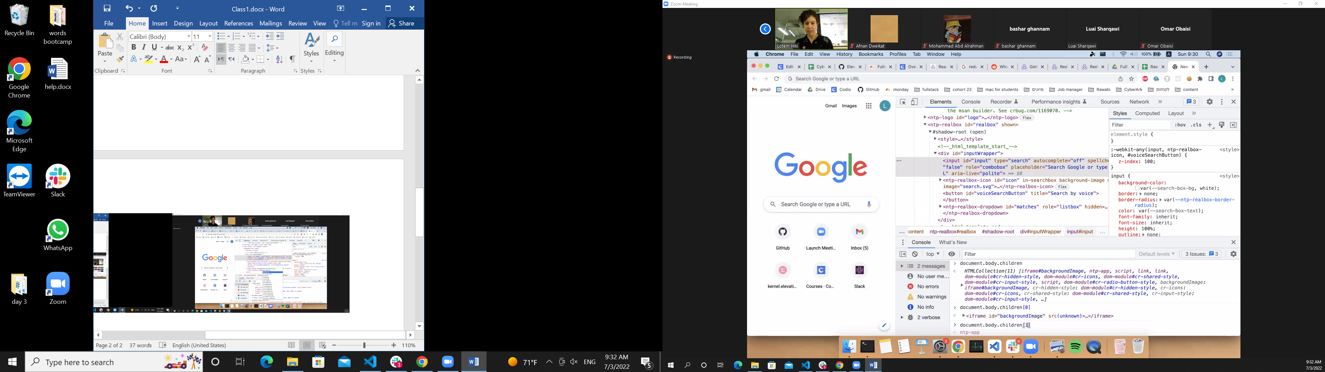

Document,body .children[1].

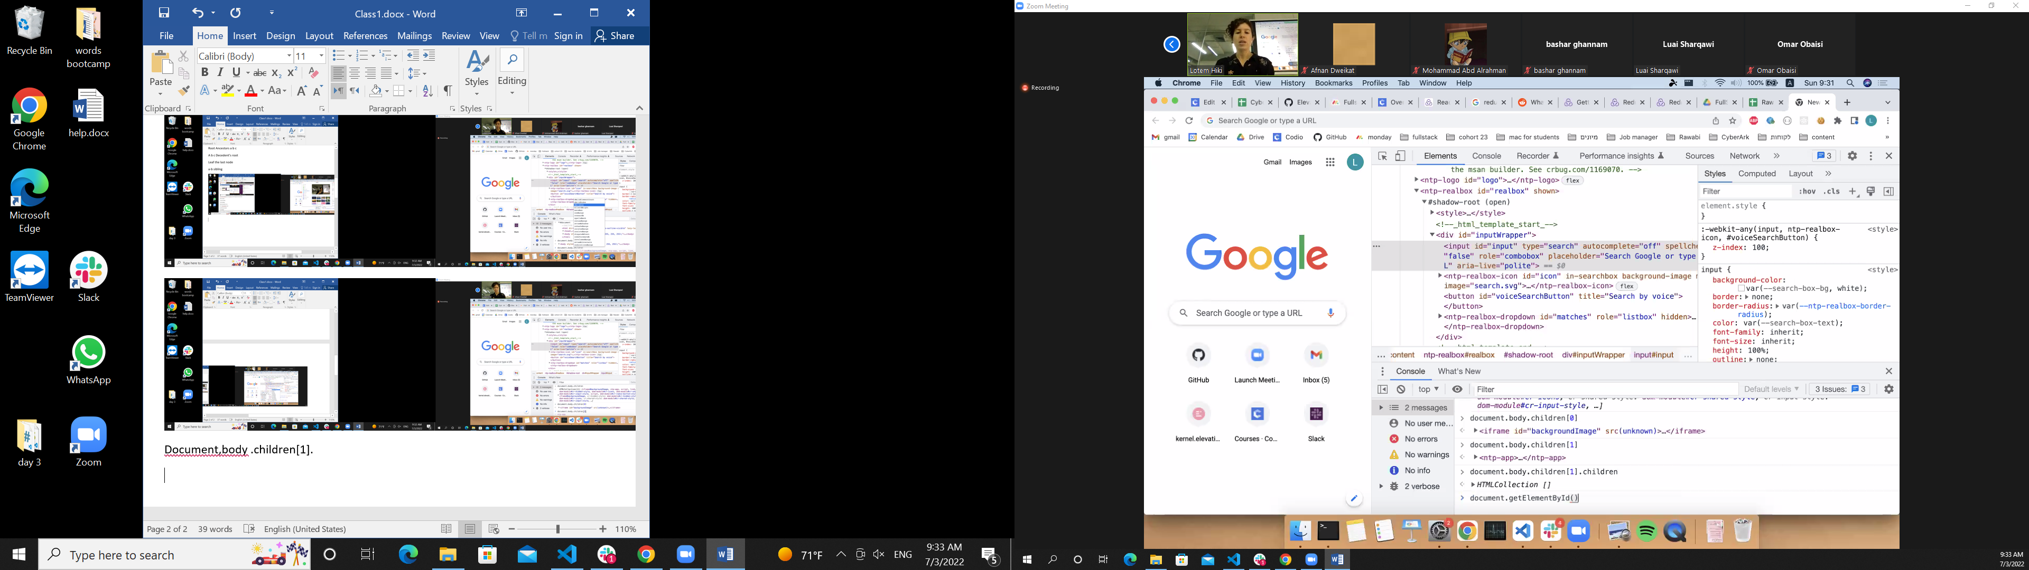

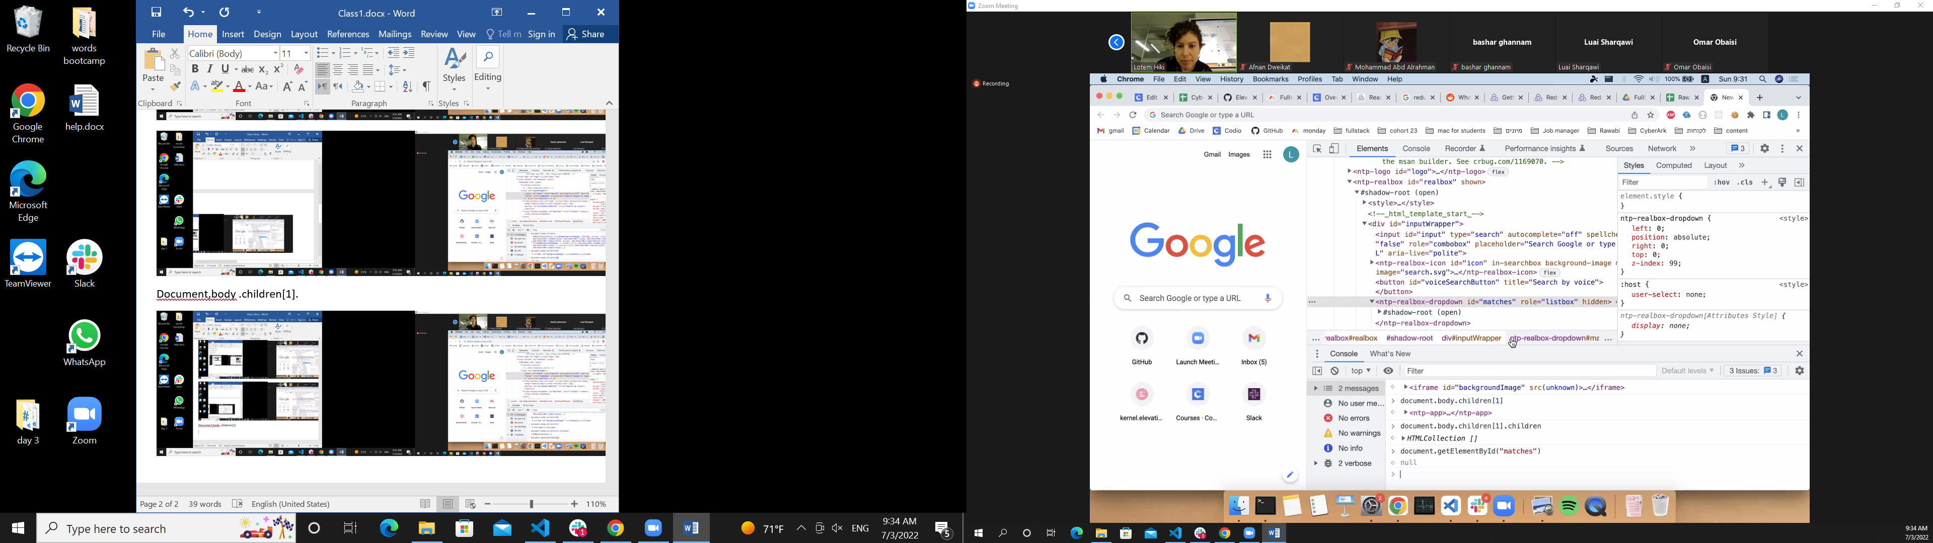

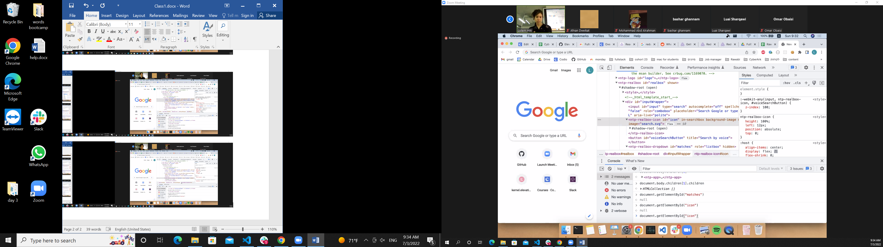

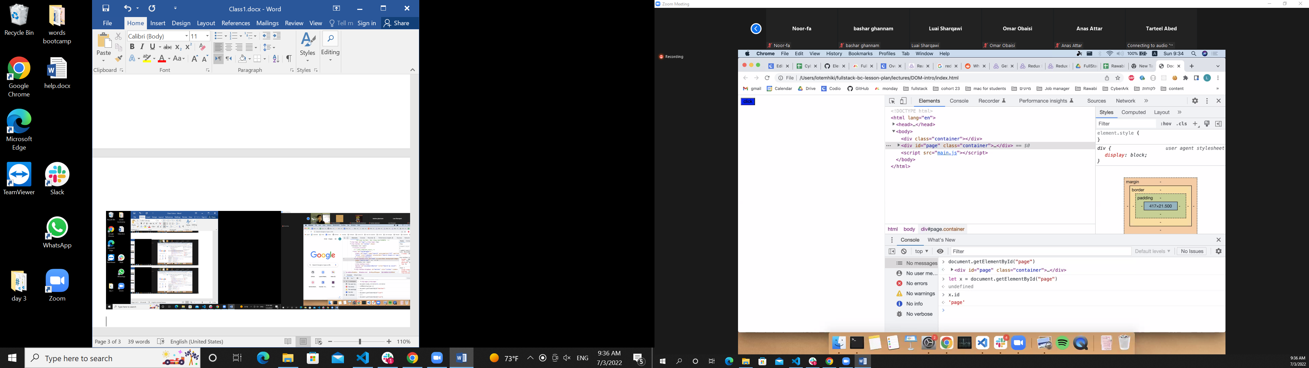

x.id

اسم الid

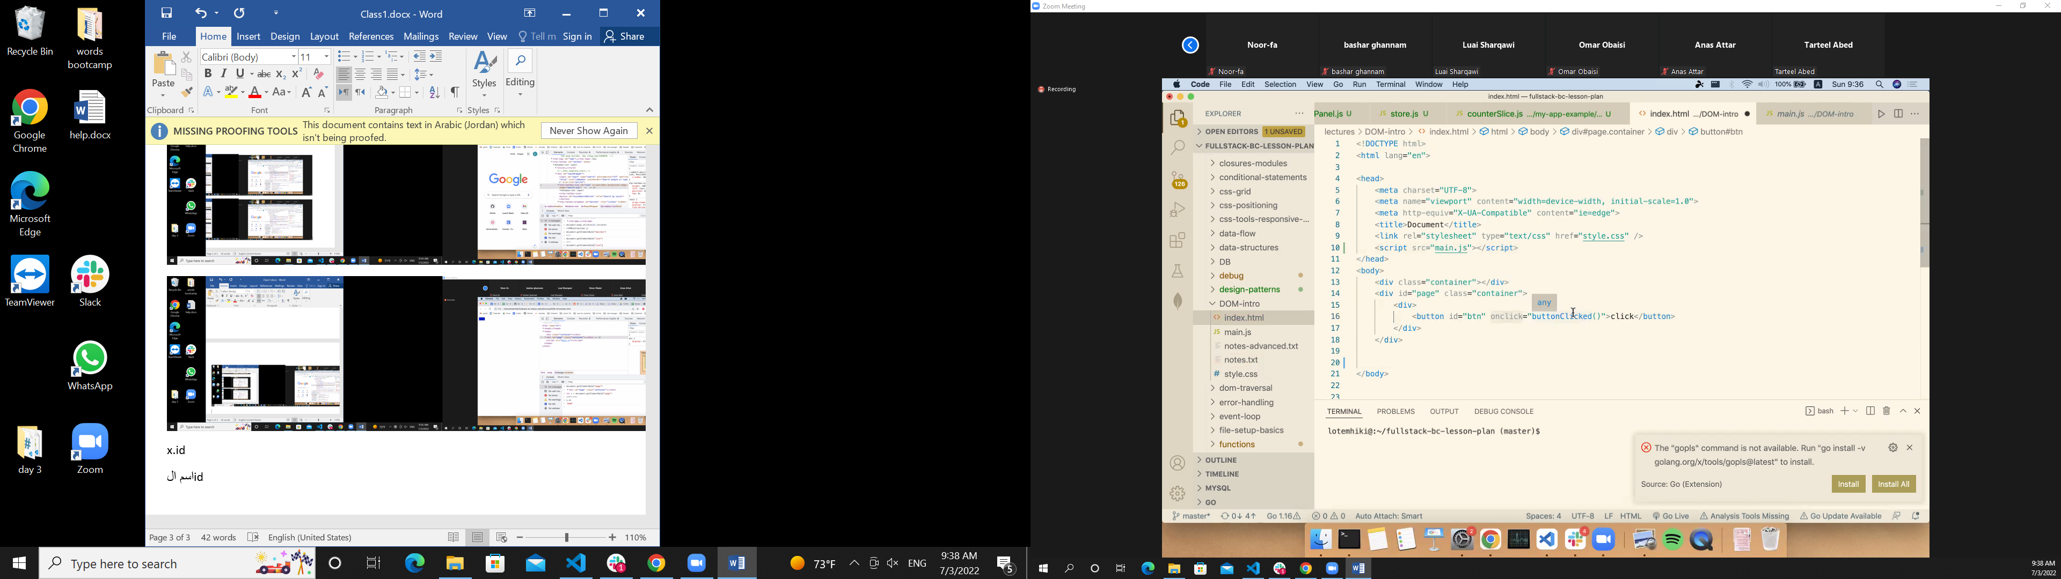

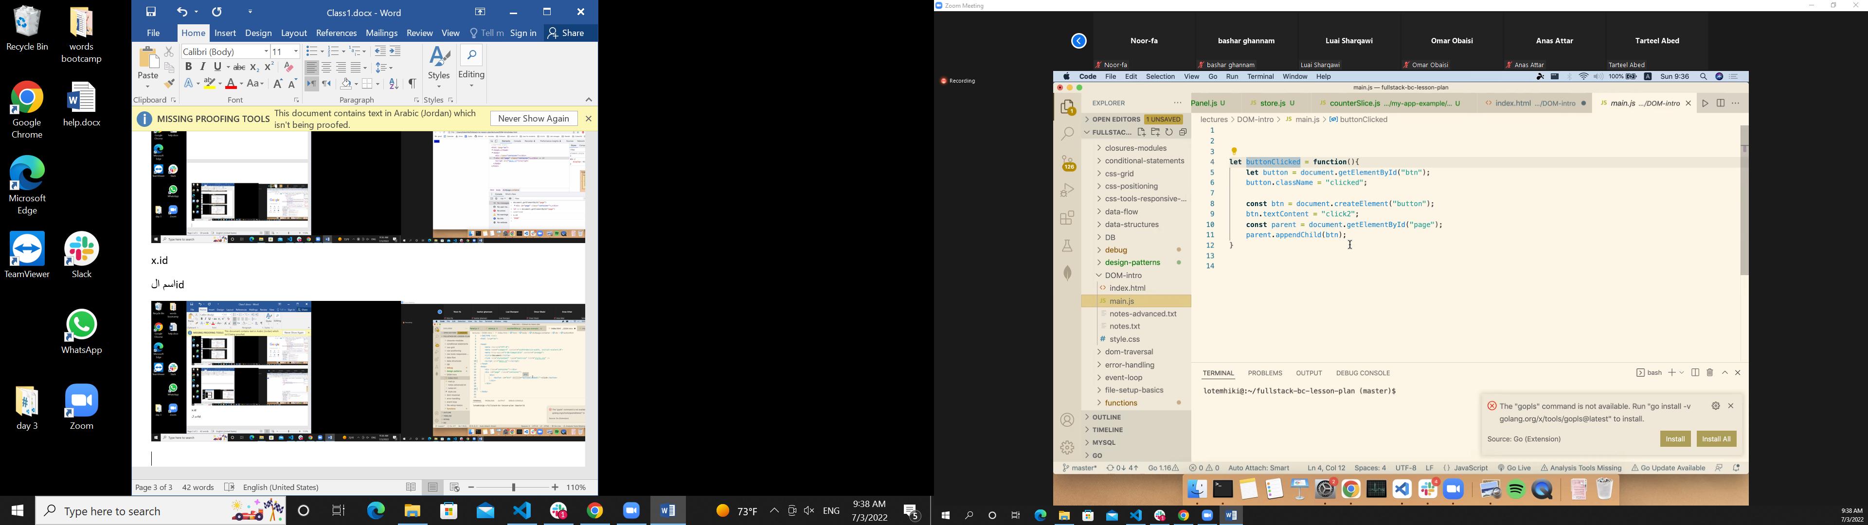

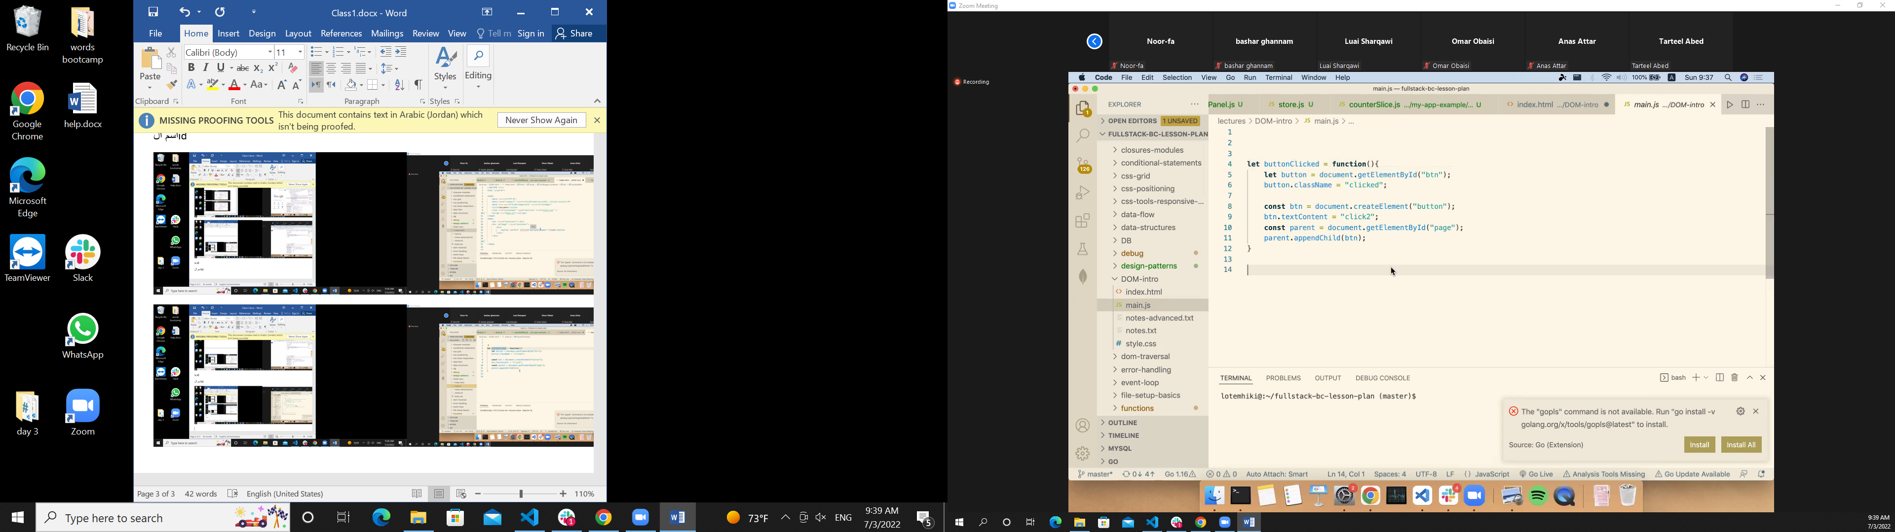

بنضاف المنت على الشاشة

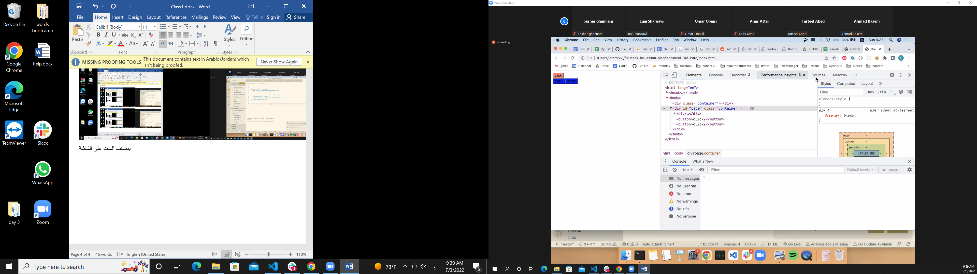

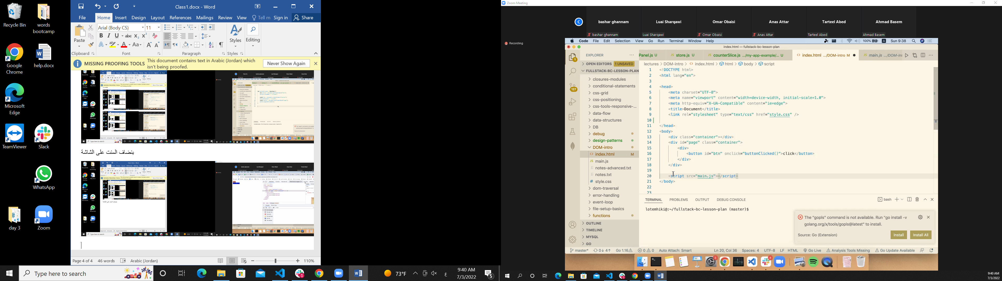

Html reload at first

Html read line by line

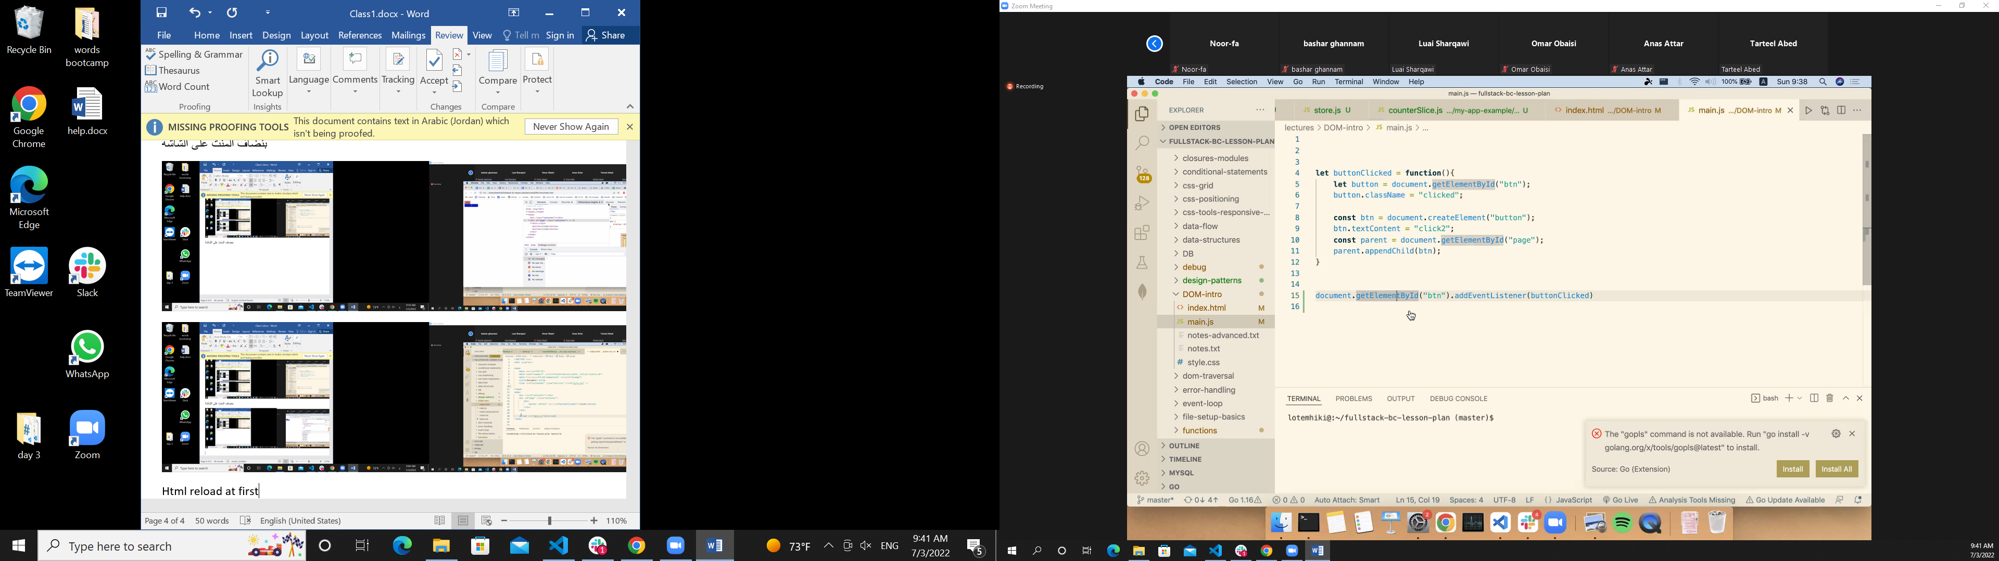

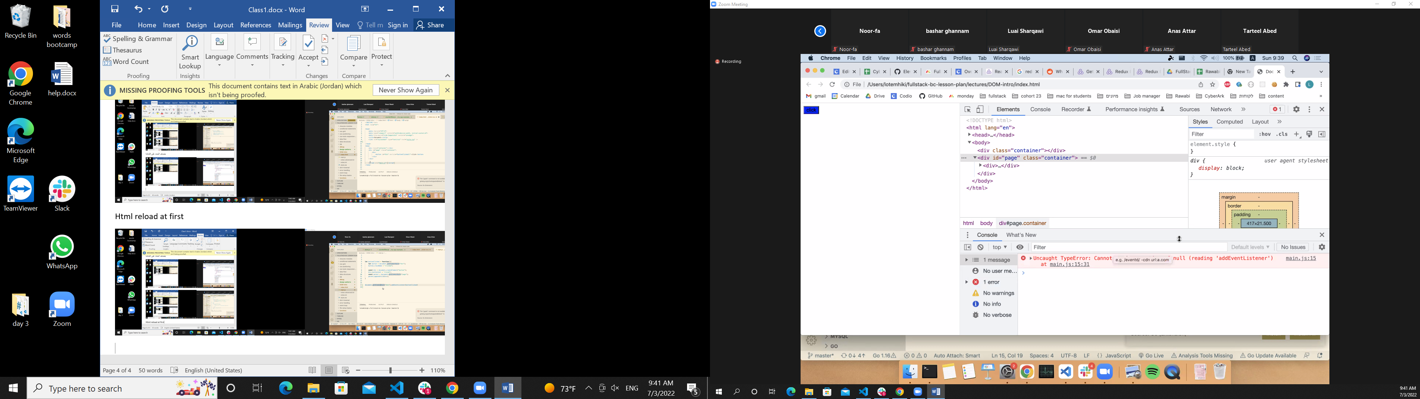

Error when we add the script in

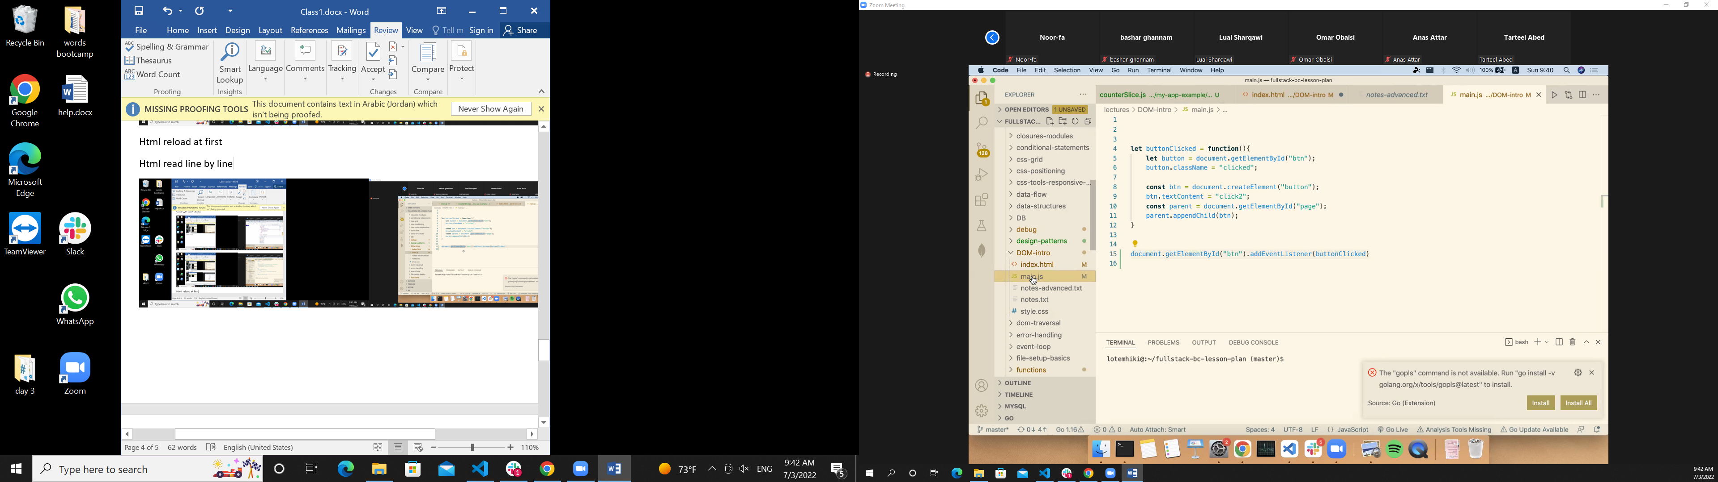

Rule who

Specifity which one is spicefic and will be ably

Inline style Id class div with class in Hamza video theres

Why inline

Element.------🡪

When we use inline element??? User input to affect my site ????

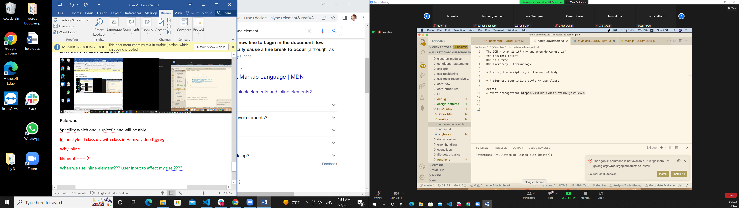

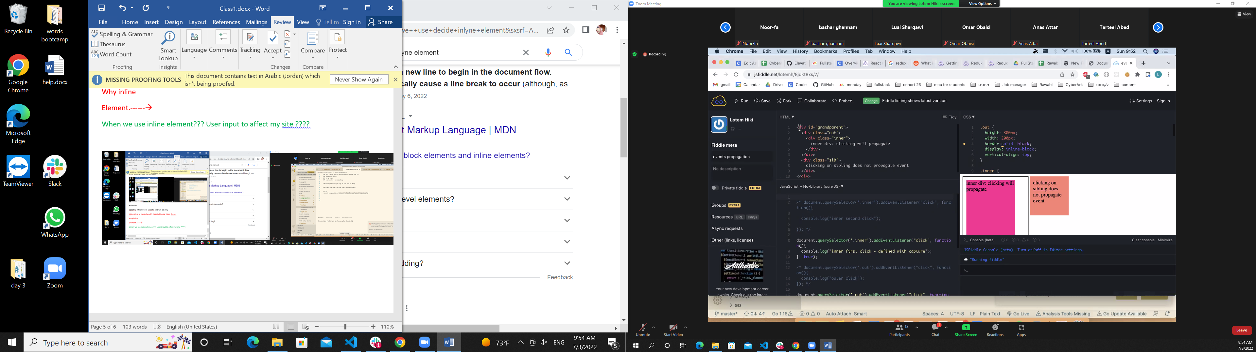

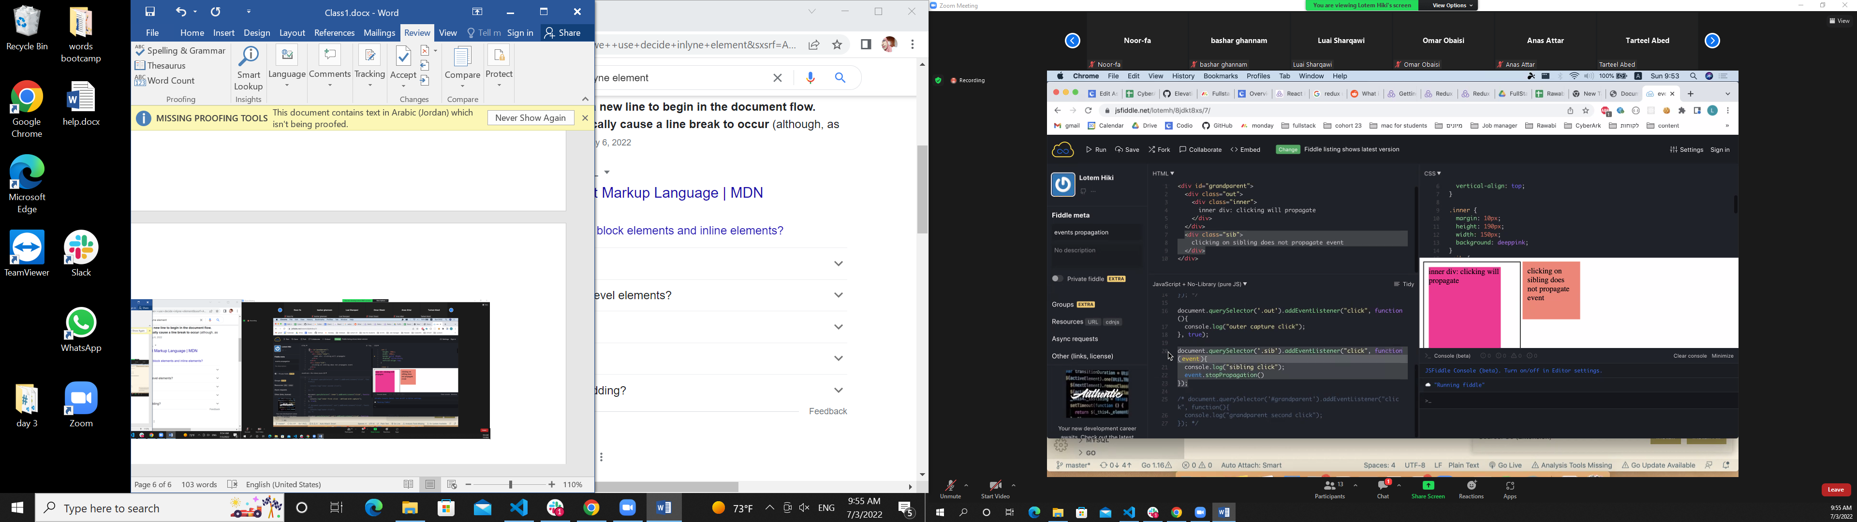

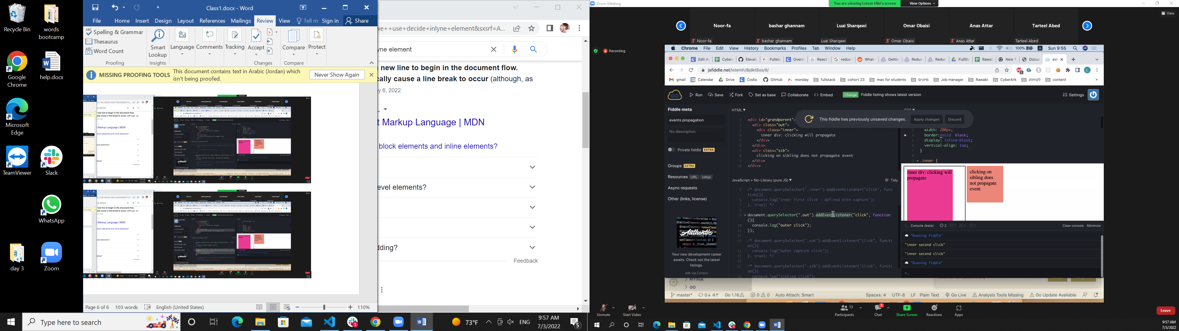

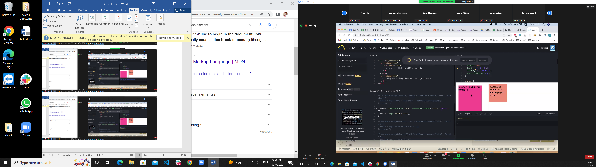 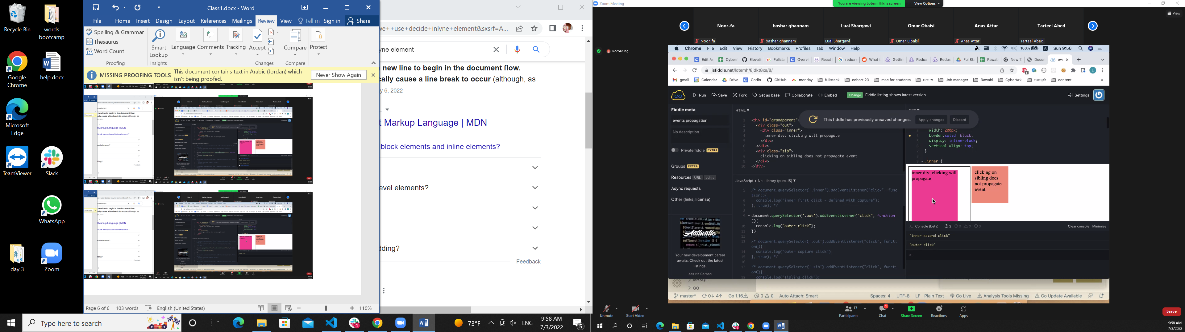

Why we propogation

Decendent

Div .bt-style

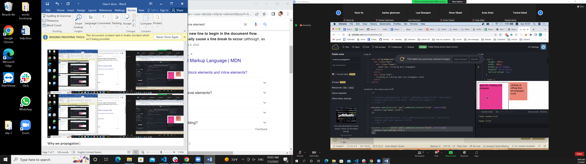

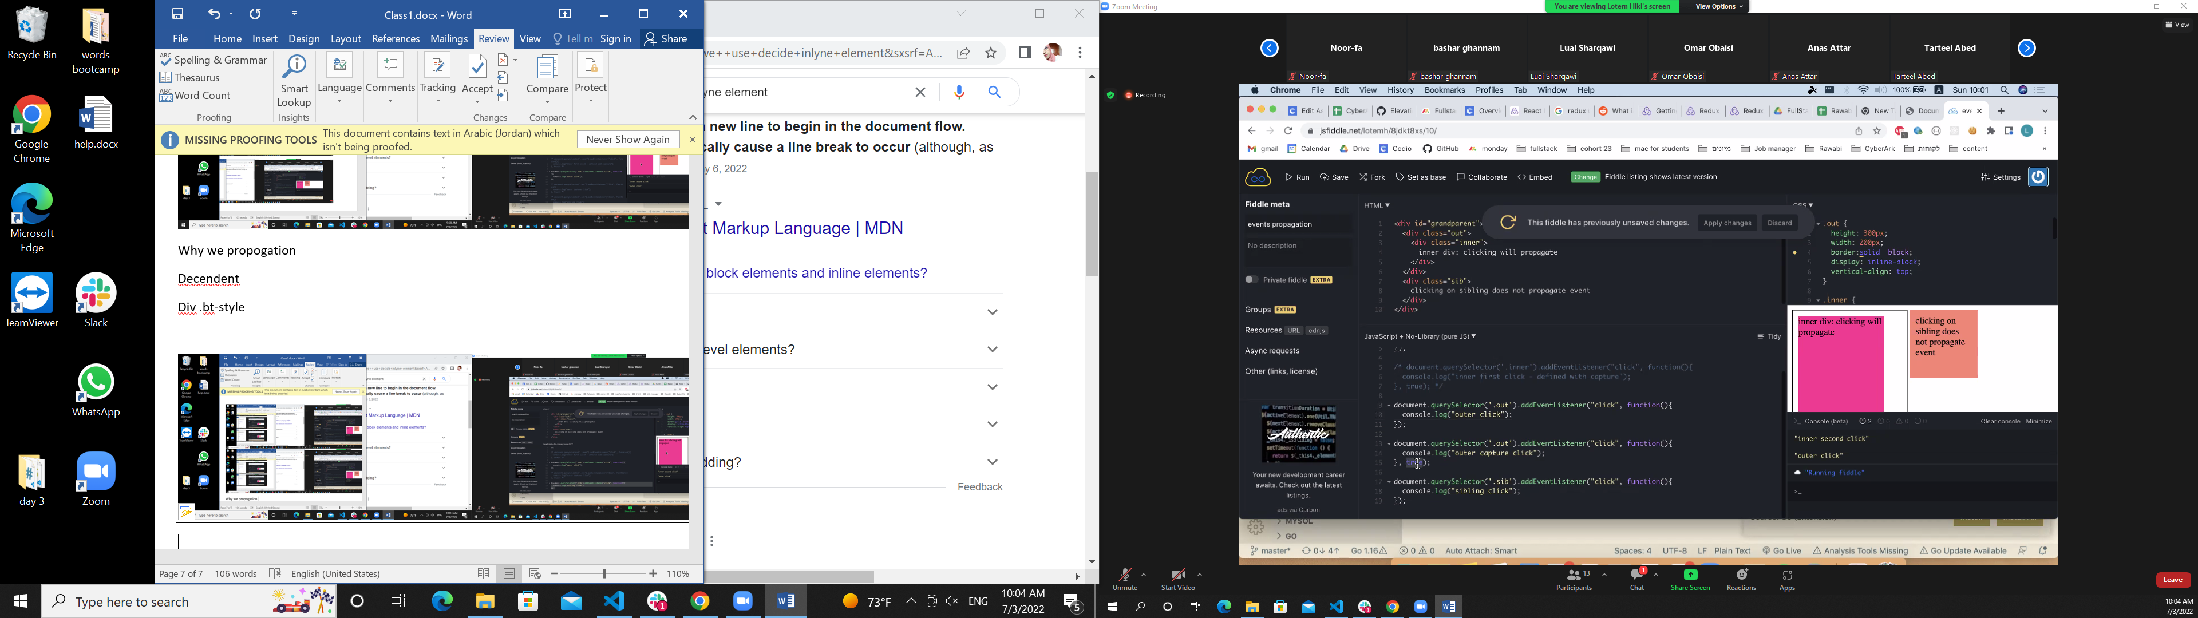

What is true parameter

<https://developer.mozilla.org/en-US/docs/Web/API/EventTarget/addEventListener>

useCapture Optional

A boolean value indicating whether events of this type will be dispatched to the registered listener before being dispatched to any EventTarget beneath it in the DOM tree. Events that are bubbling upward through the tree will not trigger a listener designated to use capture. Event bubbling and capturing are two ways of propagating events that occur in an element that is nested within another element, when both elements have registered a handle for that event. The event propagation mode determines the order in which elements receive the event. See [DOM Level 3 Events](https://www.w3.org/TR/DOM-Level-3-Events/#event-flow) and [JavaScript Event order](https://www.quirksmode.org/js/events_order.html#link4) for a detailed explanation. If not specified, useCapture defaults to false.

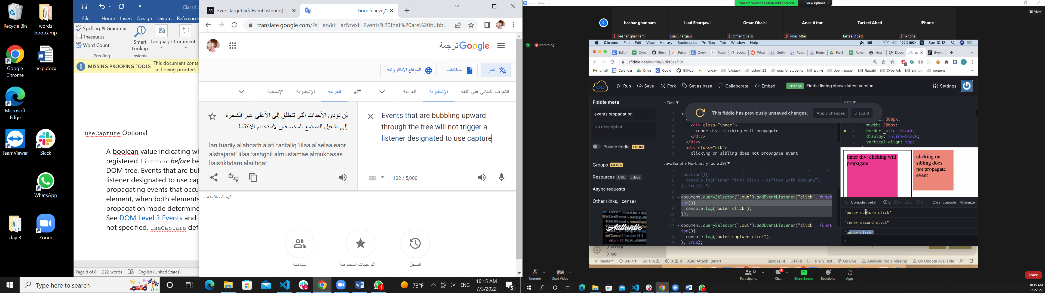

When wwe use capture and buble with option

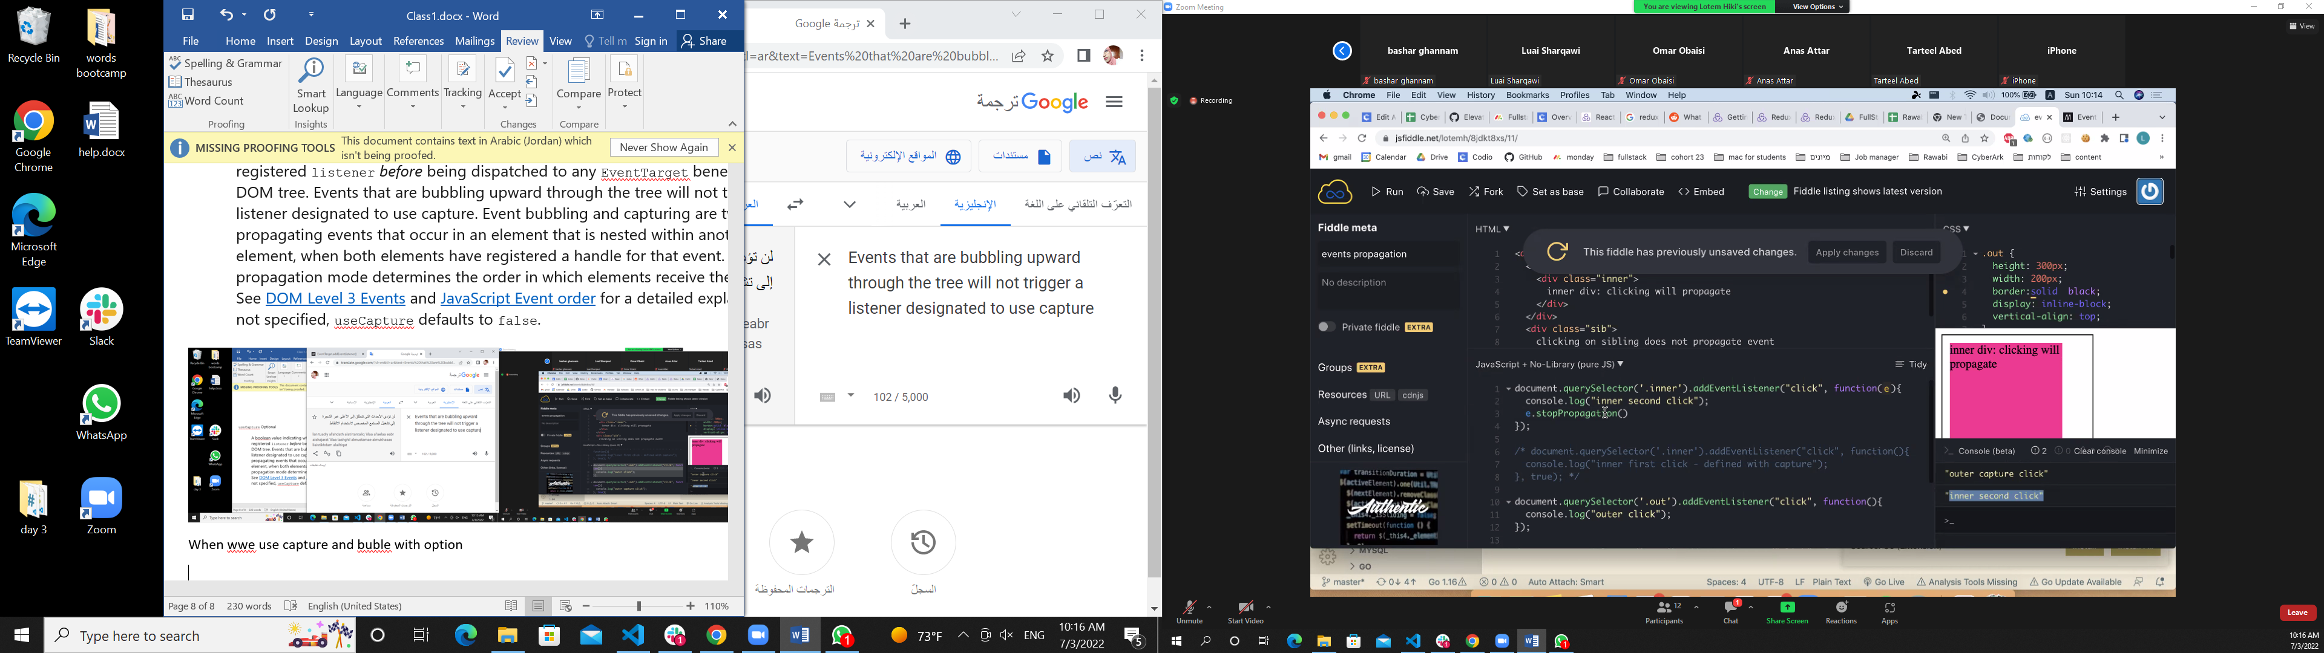

Stop the probagation stop Buble

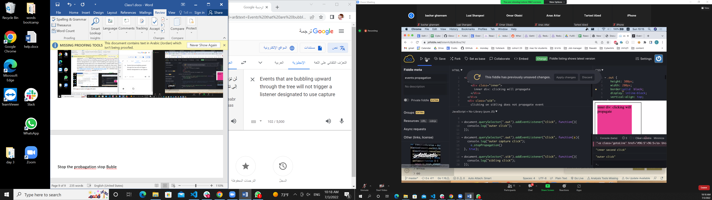

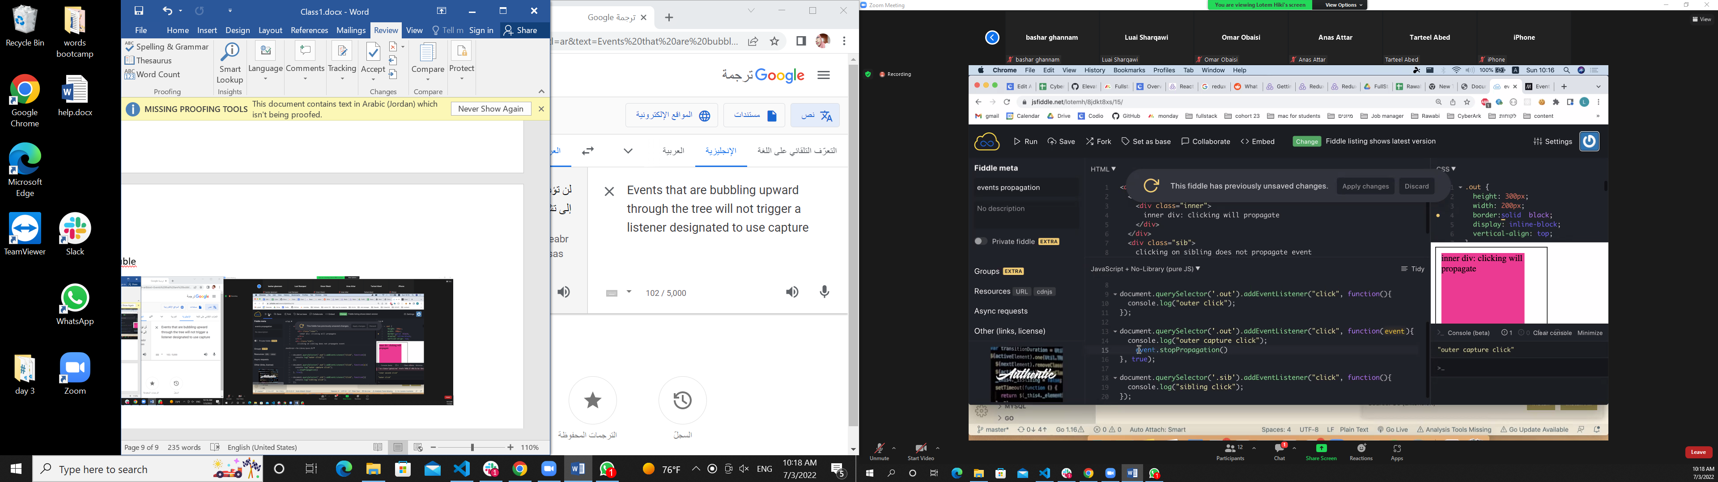

Code review??

It is a good code??

Name all the team

Only the excersies on the git hub

Week then topics ex with hint

<https://github.com/Suha523?tab=repositories>

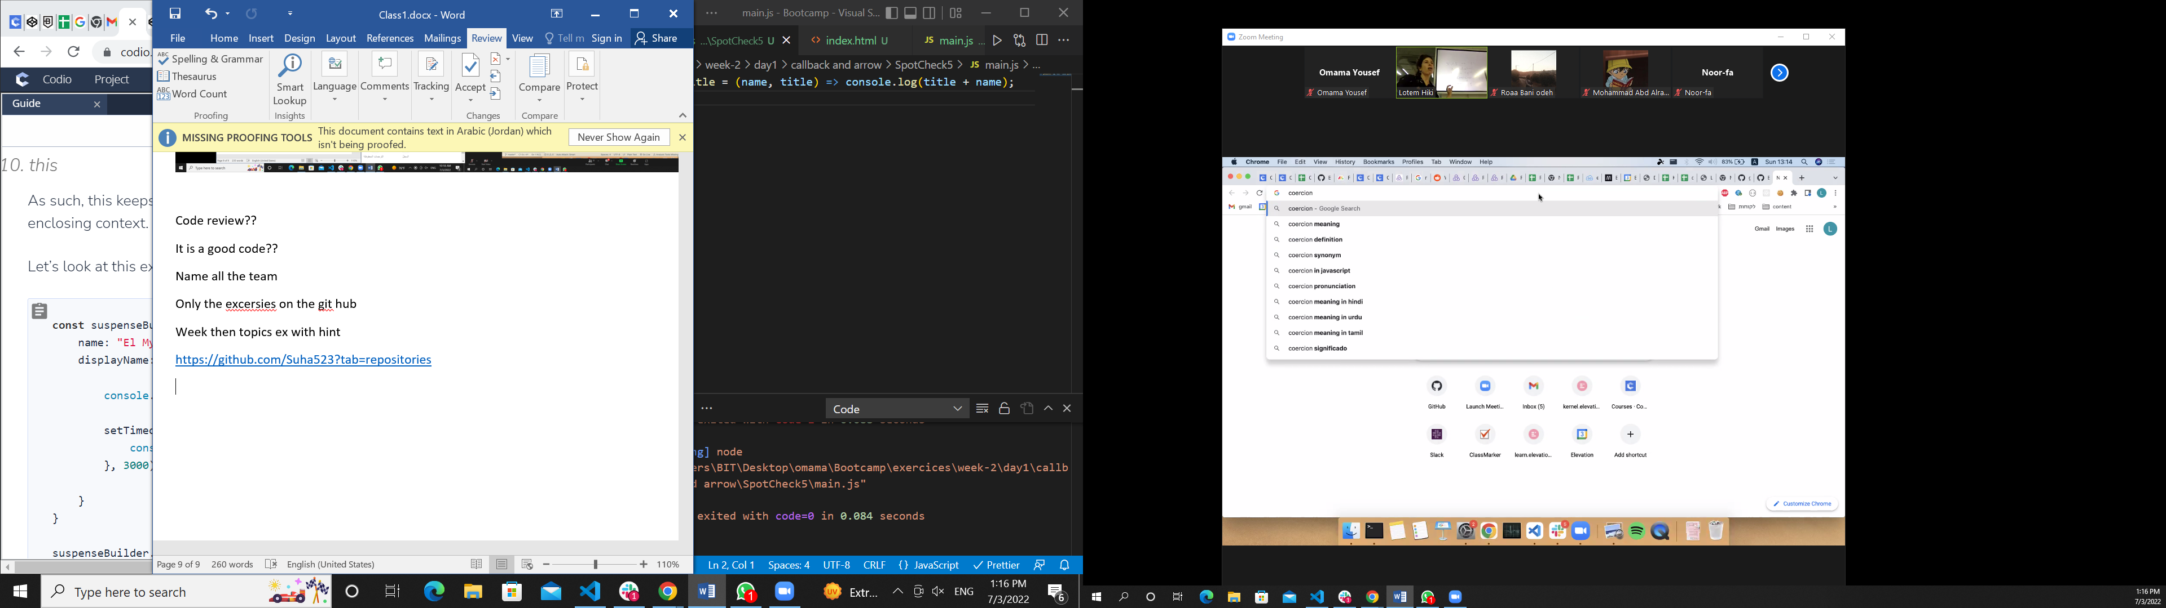

<https://github.com/MohammadHajMahmoud?tab=repositories>

like this you should

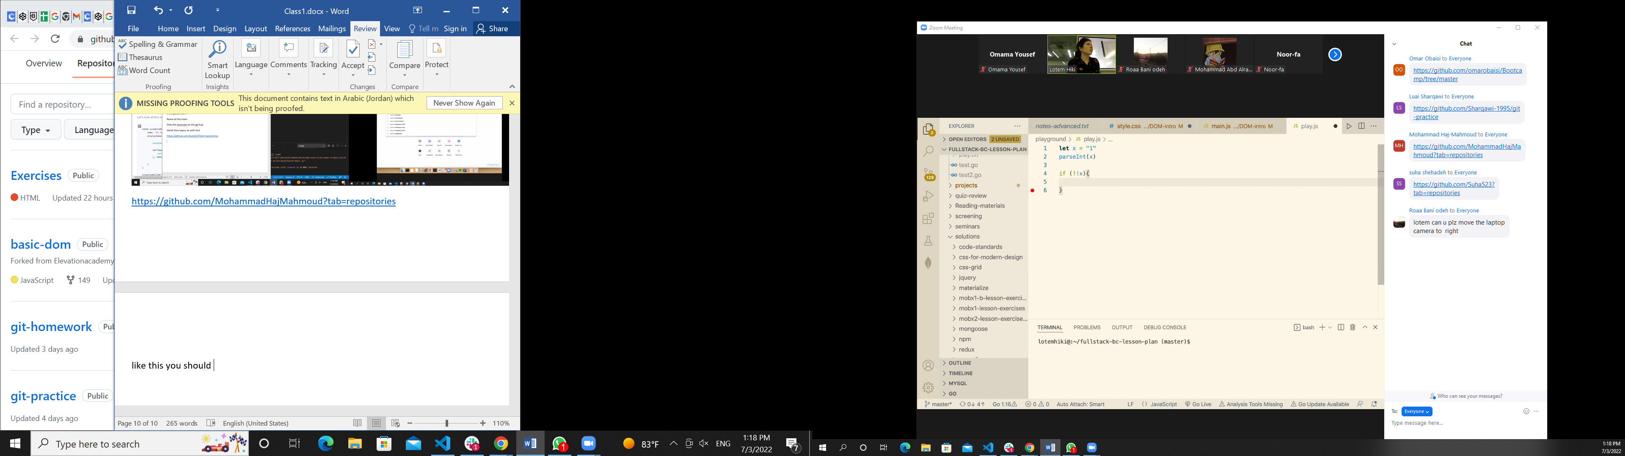

Why we write!!

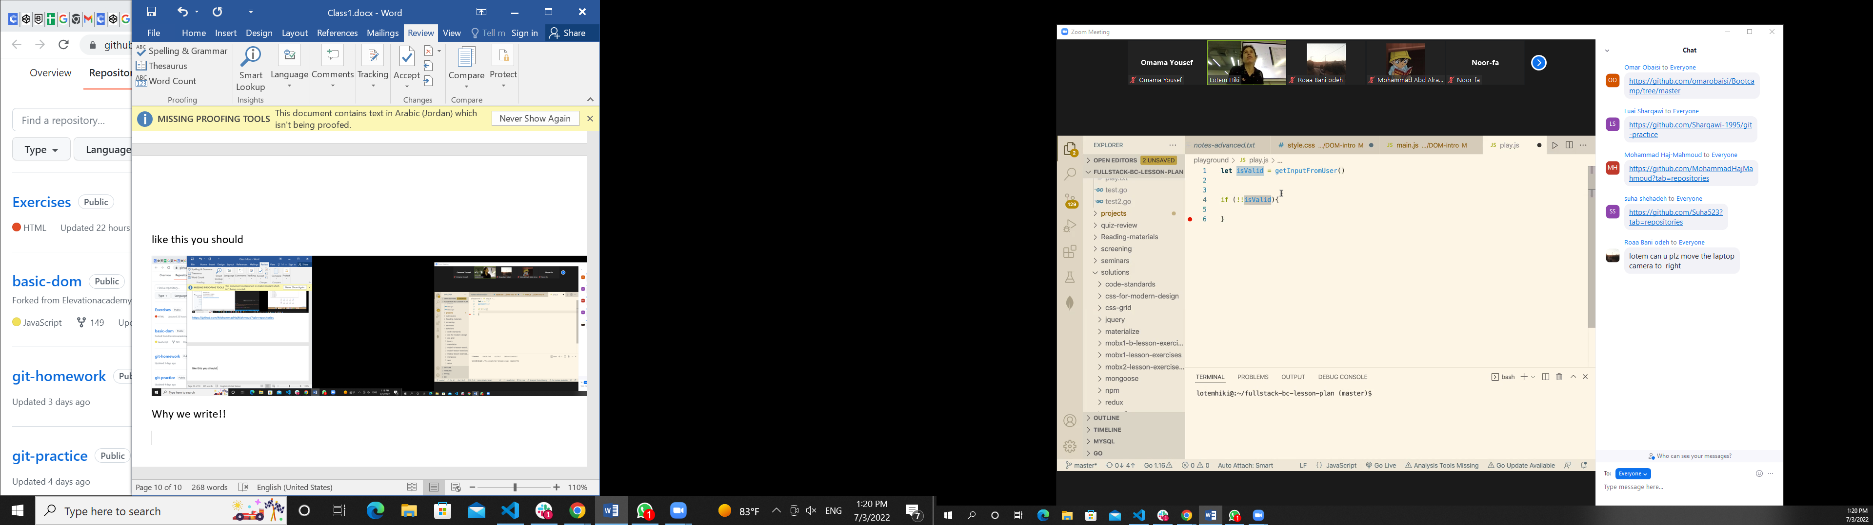

Is related to types

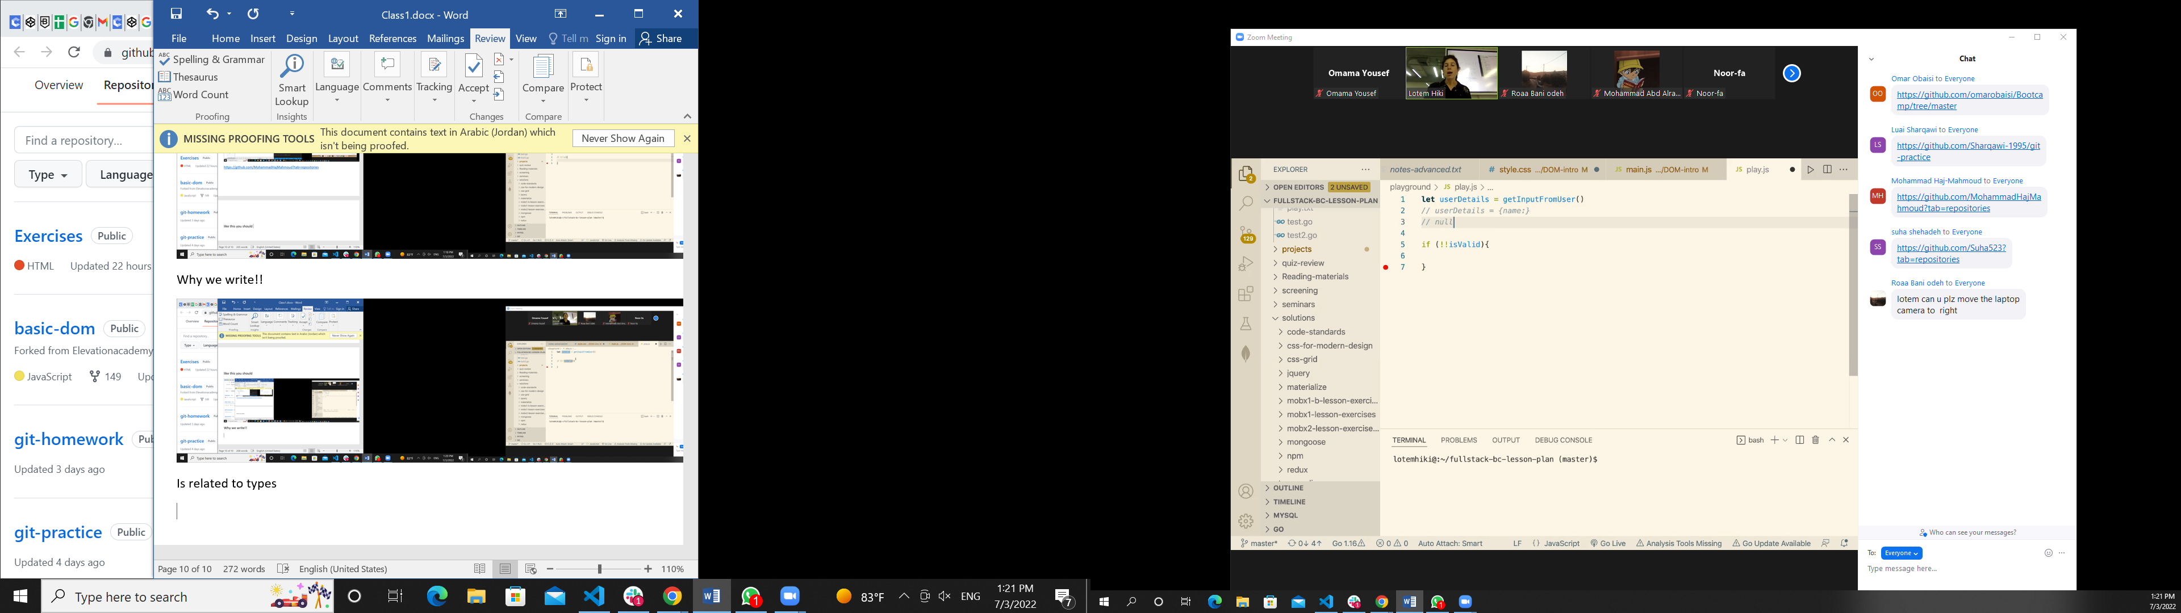

Not empty ,notnull

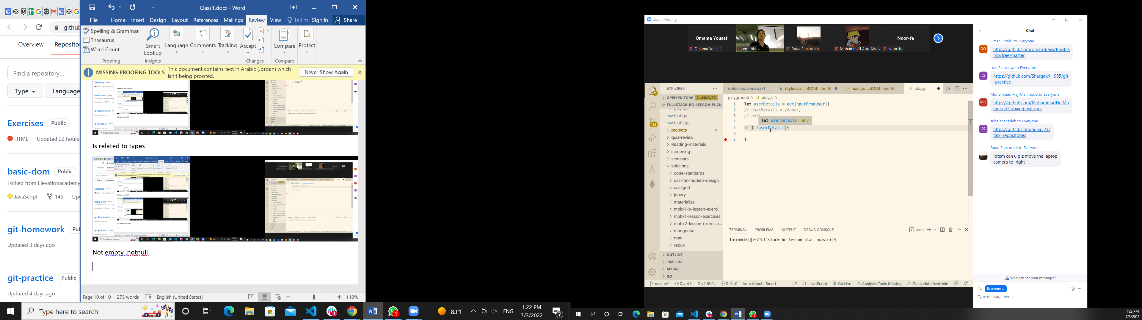

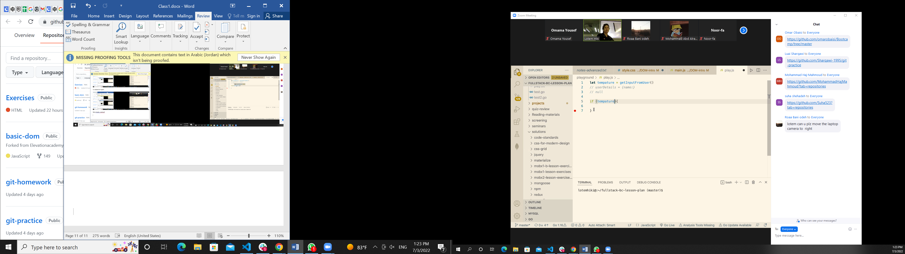

0 is false

-1 +1 is true

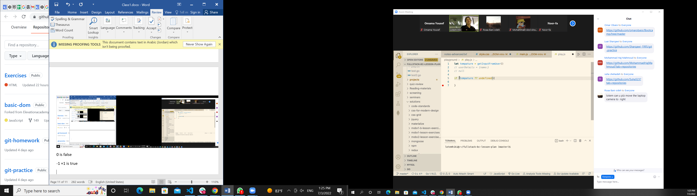

Check if null or undefined



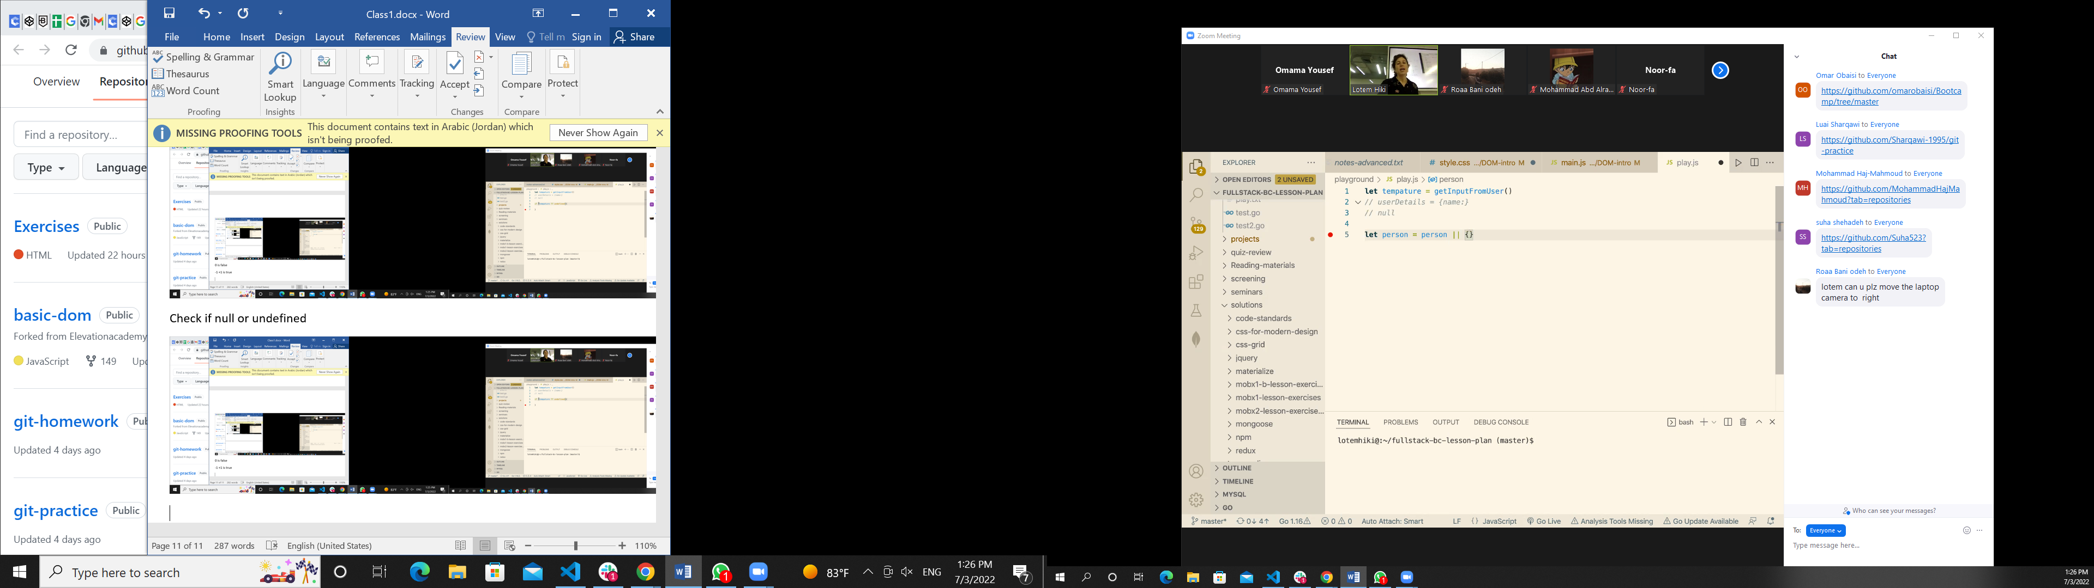

<https://github.com/omarobaisi/Bootcamp/tree/master>

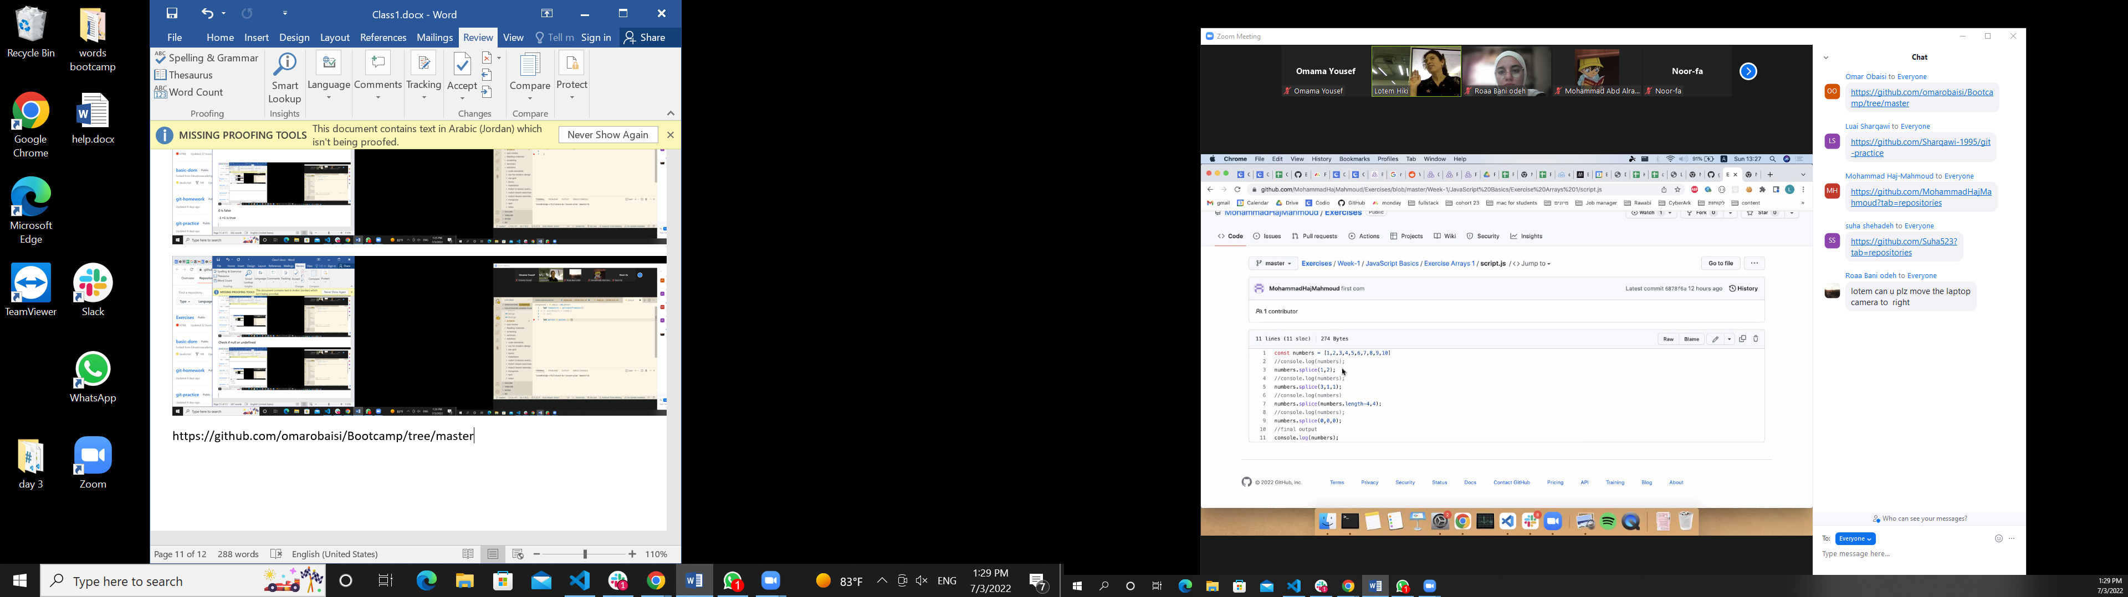

امسح رقمين من الاندكس الاول

3 باراميتر

بلش من الاندكس لثالث

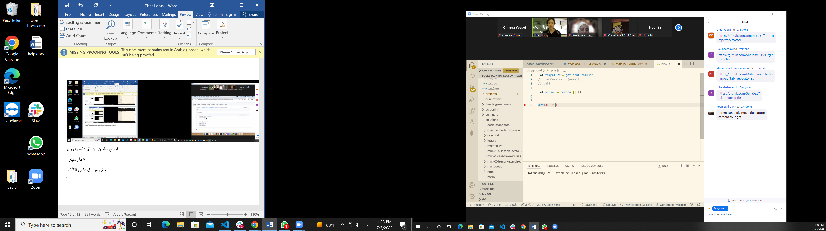

Splice (1,3,1)

Delete the last 4 element

Splice(-4)

Splice

Shift, removing

Splice(0,0,0)

Unshift

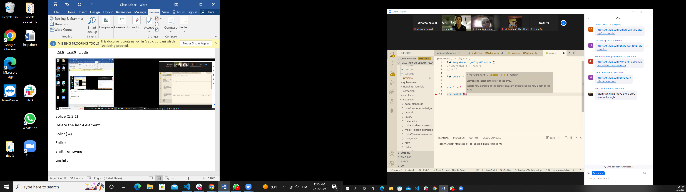

Hakathon

Hakers marathon

Project marathon in august

Not 100% work but …

2day,2night

How should it be

Iteration

Read the code and fix the bug

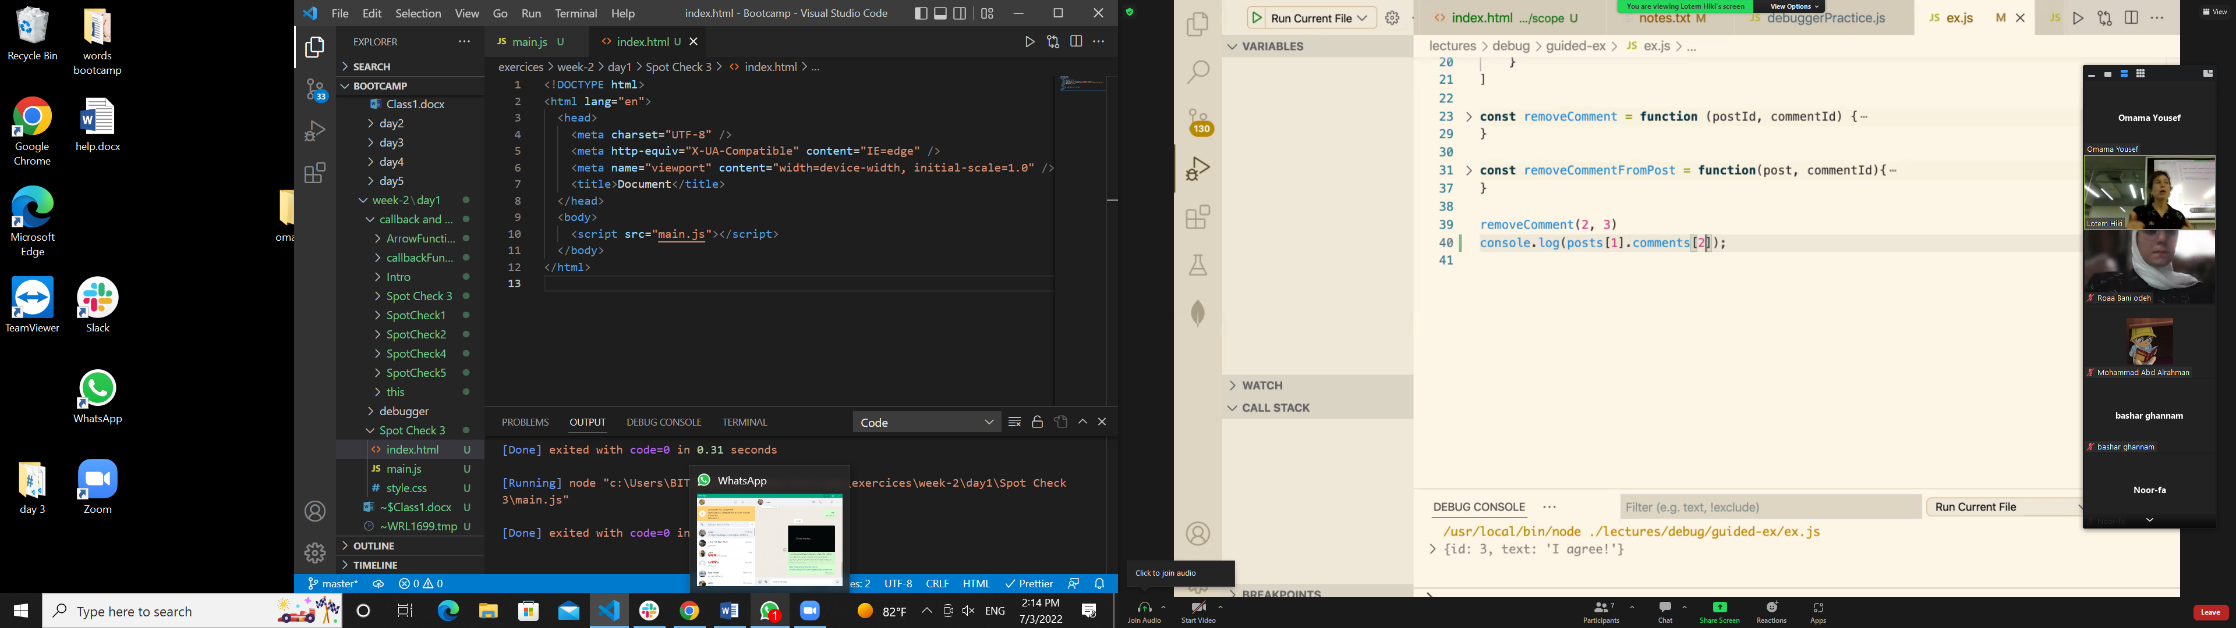

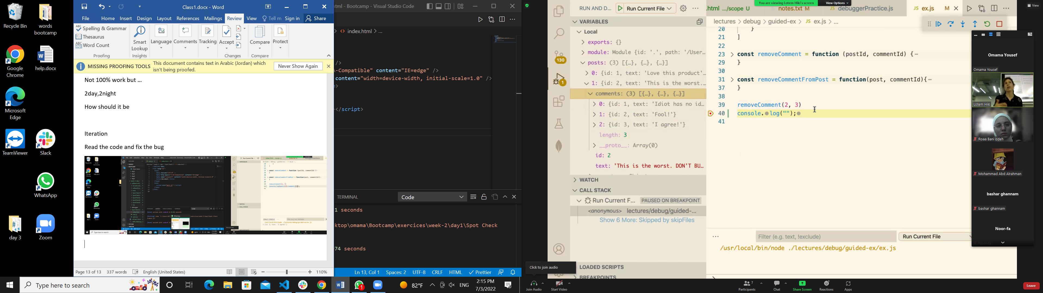

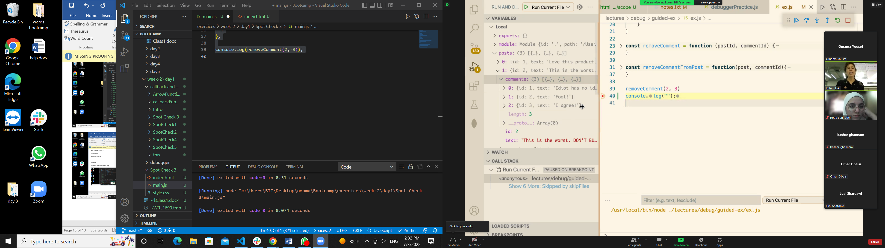

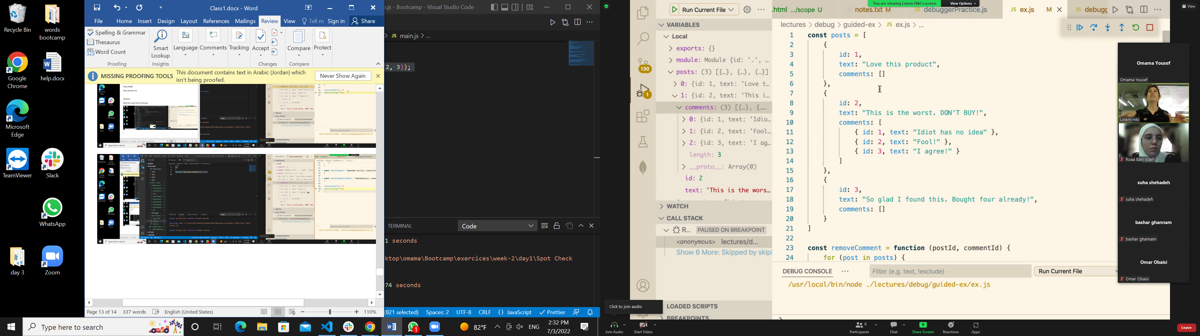

Where I should add breaking point

ايمتا احط البريك بوينت ووين

